September 17, 2025

In communication with the Pennsylvania Department of Environmental Protection, the Pike Township Municipal Authority advises that as of September 17, 2025, a voluntary Drought Watch is being issued for all customers in our service area.
As dry conditions continue and no rainfall is expected in the coming weeks, we are requesting your assistance. We are asking customers for a 5-10% reduction in ALL non-essential water use. We ask that you immediately check your service lines, and homes for leaks. Water conservation tips are included with this letter.
This Drought Watch is the first step in reducing water consumption in hope of preventing further escalation.
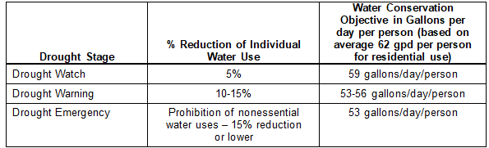
We appreciate your help and cooperation until water levels return to normal. Please contact the Authority at the information listed above with any questions or concerns.

Sincerely,

Pike Township Municipal Authority
mypikewater@outlook.com

